European Championships – FIM Europe Cup
Supplementary Regulations
Title of the meeting: |  |  |  |  |  |  |  |  |  |  |  |  |  |  |  |  | Euroepan Enduro Championship – 2nd Round
Venue: |  |  |  |  |  |  |  |  | BUZET (CROATIA)  45°24'22.9"N - 13°57'51.9"E |  |  |  |  |  |  |  |  |  |  |  |  |  |  |  |  |  |  |  |  |  |  |  |  |  |  |  |  |  |  |  |  |  |  |  |  | EMN: |  |  |  |  |  |  |  |  |  |  | 30/2
Classes: |  |  |  |  |  |  |  |  | E1 Junior, U20 Junior, E2/E3 Junior, E1, E2, E3 Senior, Veteran, Women, Trade Teams |  |  |  |  |  |  |  |  |  |  |  |  |  |  |  |  |  |  |  |  |  |  |  |  |  |  |  |  |  |  |  |  |  |  |  |  | Date: |  |  |  |  |  |  |  |  |  |  | 30-31 MAY 2015
Organizing FMN: |  |  |  |  |  |  |  |  |  |  |  |  |  |  |  |  | HMS |  |  |  |  |  |  |  |  |  |  |  |  |  |  | Country: |  |  |  |  |  |  |  |  |  |  | CROATIA
Access:
Nearest Airport: |  |  |  |  |  |  |  |  |  |  |  |  |  |  |  |  | RIJEKA (RJK) AIRP. 75KM, PULA (PUY) AIRP. 89KM, TRIESTE (TRS) AIRP. 93KM, LJUBLJANA (LJU) AIRP 120KM, VENICE (VCE) AIRP 200KM, |  |  |  |  |  |  |  |  |  |  |  |  |  |  |  |  |  |  |  |  |  |  |  |  |  |  |  |  |  |  |  |  |  |  |  |  |  |  |  |  |  |  | from the venue
Motorway: |  |  |  |  |  |  |  |  |  |  |  |  | From TRIESTE (I) – PULA (HR), after entering in Croatia , highway A9 exit 3 Nova Vas, direction Buzet
Nearest town: |  |  |  |  |  |  |  |  |  |  |  |  | BUZET |  |  |  |  |  |  |  |  |  |  |  |  |  |  |  |  |  |  |  |  |  |  |  |  |  |  |  |  |  |  |  |  | at: |  |  |  |  |  |  | 0,5 |  |  |  |  |  |  | km from the circuit
Nearest Hospital: |  |  |  |  |  |  |  |  |  |  |  |  |  |  |  |  | RIJEKA |  |  |  |  |  |  |  |  |  |  |  |  |  |  |  |  |  |  |  |  |  |  |  |  |  |  |  |  | at: |  |  |  |  |  |  | 54 |  |  |  |  |  |  | km from the venue
Hospital Address: |  |  |  |  |  |  |  |  |  |  |  |  |  |  |  |  | T. Strižića 3. 51000 RIJEKA
Phone: |  |  |  |  |  |  |  |  | +385 51 407 111 |  |  |  |  |  |  |  |  |  |  |  |  |  |  |  |  |  |  |  |  |  |  |  |  |  |  |  |  |  |  |  | EMERGENCY 112
1. ORGANIZER: |  |  |  |  |  |  |  |  |  |  |  |  |  |  |  |  | EMK Buzet
Address: |  |  |  |  |  |  |  |  |  |  |  |  | Naselje Verona 10. 52420 Buzet - Hrvatska
Phone: |  |  |  |  |  |  |  |  | +385 91 60 40 505 |  |  |  |  |  |  |  |  |  |  |  |  |  |  |  |  |  |  |  |  |  |  | Fax: |  |  |  |  |  |  |  |  | + 385 52 694 308
E-Mail: |  |  |  |  |  |  |  |  | emk.buzet@gmail.com
Web.Site: |  |  |  |  |  |  |  |  |  |  |  |  | www.emkbuzet.hr
2. ENTRIES:
Entries must be made on the official entry form and sent to the Secretary of the meeting. Entry form is available on the organizer web site. All entries must be received by (closing date) 30.APRIL 2015. (30 days before the meeting)
Address: |  |  |  |  |  |  |  |  |  |  | Naselje Verona 10. 52420 Buzet - Hrvatska
Phone: + |  |  |  |  |  |  |  | +385 98 260 528 |  |  |  |  |  |  |  |  |  |  |  |  |  |  |  |  |  |  |  |  |  |  |  |  |  |  |  | Fax: + |  |  |  |  |  |  |  |  |  |  |  |  | +385 52 694 308
E-Mail: |  |  |  |  |  |  |  | emk.buzet@gmail.com
Bank details: Istarska kreditna banka Umag d.d. Entry fee: 140€
Address: ERNESTA MILOSA 1. UMAG
BIC/SWIFT: ISKBHR2X
Account number IBAN: HR6923800061146002706
Payment not later than: |  |  |  |  |  |  |  |  |  |  |  |  |  |  |  |  |  |  |  | 15 MAY 2015 |  |  |  |  |  |  |  |  |  |  |  |  |  |  |  |  |  |  |  |  |  | (15 days before the meeting)
3. SECRETARIAT OF THE MEETING:
Address: |  |  |  |  |  |  |  |  |  |  | Hotel Fontana , Trg Fontana 1. 52420 Buzet - Hrvatska
Phone: + |  |  |  |  |  |  |  | +385 91 662 2717 |  |  |  |  |  |  |  |  |  |  |  |  |  |  |  |  |  |  |  |  |  |  |  |  |  |  |  | Fax: + |  |  |  |  |  |  |  |  |  |  |  |  | +385 52 694 308
E-Mail: |  |  |  |  |  |  |  | emk.buzet@gmail.com
4. WELCOME CENTER:
Place: |  |  |  |  |  |  |  | Paddock – Parking place Buzet
Open on: |  |  |  |  |  |  |  |  |  |  | Thursday: |  |  |  |  |  |  |  |  |  |  |  |  |  |  | from: |  |  |  |  |  |  |  | 09:00 |  |  |  |  |  |  |  |  |  |  |  |  |  |  |  |  |  |  |  |  |  |  |  |  | to: |  |  |  |  |  |  |  | 18:00
 |  |  |  |  |  |  |  |  |  |  | Friday: |  |  |  |  |  |  |  |  |  |  |  |  |  |  | from: |  |  |  |  |  |  |  | 09:00 |  |  |  |  |  |  |  |  |  |  |  |  |  |  |  |  |  |  |  |  |  |  |  |  | to: |  |  |  |  |  |  |  | 18:00
5. OFFICIALS:
Jury President: |  |  |  |  |  |  |  |  |  |  |  |  |  |  |  |  |  | Sasvári Sándor |  |  |  |  |  |  |  |  |  |  |  |  |  |  |  |  |  |  |  |  |  |  |  |  |  |  |  |  |  |  |  |  |  |  |  |  |  | FIM Lic. Nr. |  |  |  |  |  |  |  |  |  |  |  |  | 10021
FMNR-Jury Member: |  |  |  |  |  |  |  |  |  |  |  |  |  |  |  |  |  |  | Emil Jurada |  |  |  |  |  |  |  |  |  |  |  |  |  |  |  |  |  |  |  |  |  |  |  |  |  |  |  |  |  |  |  |  |  |  |  |  | FIME Lic. Nr. |  |  |  |  |  |  |  |  |  |  |  |  | tbc
Secretary of the Jury: |  |  |  |  |  |  |  |  |  |  |  |  |  |  |  |  |  |  | tbc
Clerk of the course: |  |  |  |  |  |  |  |  |  |  |  |  |  |  |  |  |  |  | Valter Majer |  |  |  |  |  |  |  |  |  |  |  |  |  |  |  |  |  |  |  |  |  |  |  |  |  |  |  |  |  |  |  |  |  |  |  |  | FIME Lic. Nr. |  |  |  |  |  |  |  |  |  |  |  |  | tbc
Secretary of the Meeting: |  |  |  |  |  |  |  |  |  |  |  |  |  |  |  |  |  |  | David Krajcar
Chief Technikal Steward: |  |  |  |  |  |  |  |  |  |  |  |  |  |  |  |  |  |  | Igor Gržinić |  |  |  |  |  |  |  |  |  |  |  |  |  |  |  |  |  |  |  |  |  |  |  |  |  |  |  |  |  |  |  |  |  |  |  |  | FIME Lic. Nr. |  |  |  |  |  |  |  |  |  |  |  |  | tbc
Chief Timekeeper: |  |  |  |  |  |  |  |  |  |  |  |  |  |  |  |  |  |  | tbc |  |  |  |  |  |  |  |  |  |  |  |  |  |  |  |  |  |  |  |  |  |  |  |  |  |  |  |  |  |  |  |  |  |  |  |  | FIM Lic. Nr.
Environmental Steward: |  |  |  |  |  |  |  |  |  |  |  |  |  |  |  |  |  |  | Renata Suchy |  |  |  |  |  |  |  |  |  |  |  |  |  |  |  |  |  |  |  |  |  |  |  |  |  |  |  |  |  |  |  |  |  |  |  |  | FIM Lic. Nr. |  |  |  |  |  |  |  |  |  |  |  |  | tbc
Chief Medical Officer: |  |  |  |  |  |  |  |  |  |  |  |  |  |  |  |  |  |  | tbc
Press Officer: |  |  |  |  |  |  |  |  |  |  |  |  |  |  |  |  |  |  |  | tbc
FMN-Delegates according to the Art. 50.6 of the FIME Sporting Code.
Closing date for entrys of FMN Delegates is 15 Days before the Meeting
The meeting will be organized in conformity with the FIME Sporting Code, the FIME & FIM ENDURO, the
E & R Commission Regulations, the general rules of the (FMNR), where applicable, and this
Supplementary Regulations which have been duly examined and approved by the (FMNR).
6. STARTING NUMBERS:
See Art. 01.14.3 CLASS NUMBERS and Art. 01.16.1.2 NUMBER PLATES of Enduro Rules
From the second event onwards the riders will start class by class in their respective classes following the order determined by the provisional classification of the previous rounds.
7. RECONNAISSANCE OF THE COURSE

 | Meeting point: At the start, on 11:00 Friday 29.May 2015. at starting zone.
8. ADMINISTRATIVE AND TECHNICAL INSPECTIONS
 | Administrative inspection from 10:00 to 16:00 on Friday 29.May 2015.
 | Tecnical inspections: from 11:00 to 17:00 on Friday 29.May 2015.
See attached Time Schedule
9. JURY MEETINGS
The First Jury meeting will be held at 09:00 Friday 29.May 2015.in Hotel Fontana. Buzet
Subsequent Jury meetings will be at times decided by the Jury President and these times will be displayed on the Jury room door
13. AREA TRAINING:
At 1 km from the paddock and open 28.05.2015. from 15:00 to 17:00 and 29.05.2015 from 09:00 to 12:00.
14. COURSE:
DAY 1:The course for the first day shall consist of 3 laps of a 60 km course which will include 2 time- checks/lap.
There will be a total of 2 special tests in each lap, First is Motocross test (MX), and second is Enduro test (ET).
DAY 2:The course for the second day shall consist of 3 laps of a 60 km course which will include 2 time- checks/lap.
There will be a total of 2 special tests, first is Motocross test (MX), and second is Enduro test (ET).
The location and length of each test shall be displayed at (venue) from (time) (at least 48 hours before).
Start of the race : at 09:00 AM both days
15. FUEL:
In according with FIM specifications.
16. INSURANCE:
 |  |  |  | By endorsing the application form for entry, the FNM of the rider certifies that the rider is insured in according with the FIME requirements.
 |  |  |  | The organizer has contacted a third party insurance in according with Art. 110.1 of the FIME Sporting Code. This insurance includes a guarantee of the minimum amount as stipulated by the FIME Management Council. The Insurance comes in effect 2 days before the first practise and ends 2 days after the meeting.
 |  |  |  | The organizer disclaims all responsibility for damage to a motorcycle, its accessories and components arising out of an accident, fire or other incident.
17. PROTEST AND APPEALS:
 |  |  |  | Any person or group of persons (rider, entrant, manufacturer, official, etc.), recognized by the FIM and concerned by a decision taken under the authority of the FIME, may ask for redress for the consequences of that decision.
 |  |  |  | Protest must be lodged according to the FIME Disciplinary and Arbitration Code and the Supplementary Regulations and be accompanied by a fee of 130,- € or equivalent amount in local currency, returnable if the protest is justified.
 |  |  |  | In general, protests against eligibility of a rider entered, must be made before the start of the official practice.
 |  |  |  | Protests against results must be presented to the International Jury within 30 minutes following the publishing of the results.
 |  |  |  | An appeal can be made to the FIME Disciplinary Commission against a decision of the International Jury.
 |  |  |  | Protest entailing a fuel control: See FIME MX rulebooks.
23. PRICE-GIVING CEREMONY:
 |  |  |  | Venue of the prize-giving ceremony:
 |  |  |  | Riders who qualify for prizes are invited to attend the prize-giving ceremony in paddock.
 |  |  |  | If invited attendance to the prize giving ceremony or press conference is compulsory.
24. INTERPRETATION OF THE SUPPLEMENTARY REGULATIONS:
 |  | The interpretation of this regulations rests entirely with the Jury. In case of dispute, regarding the interpretation or if there is any difference between the two official texts, the English text will prevail.
25. MISCELLANEOUS:
 |  |  |  | The maximum fee for Transponders rent is 100.-€, the fee has to be returned after the transponder is received back.
Place and date: |  |  |  |  |  |  |  |  |  |  |  |  |  |  |  |  |  |  |  |  |  |  |  |  |  |  |  |  |  |  | Buzet 25.03.2015.
The press office is equipped with a high speed internet connection over the whole meeting.
The Clerk of the Course: |  |  |  |  |  |  |  |  |  |  |  |  |  |  | Majer Valter
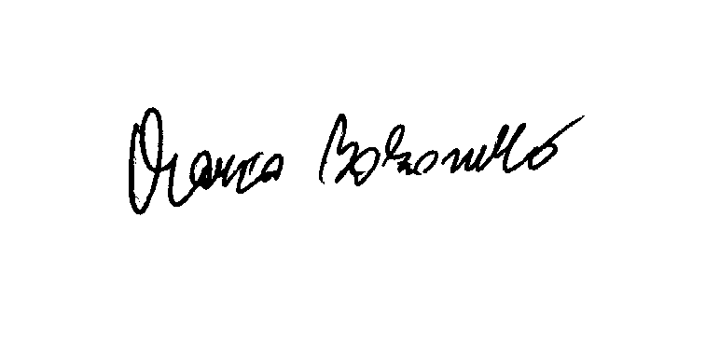  Approved by FMNR: |  |  |  |  |  |  |  |  |  |  |  |  |  |  | HMS
Approved by FIME: |  |  |  |  |  |  |  |  |  |  |  | M. Bolzonello- Fime E&R Commission,  Rome 30.3.2015
Attachment:
A map of the region, including the venue of the circuit
Time Schedule

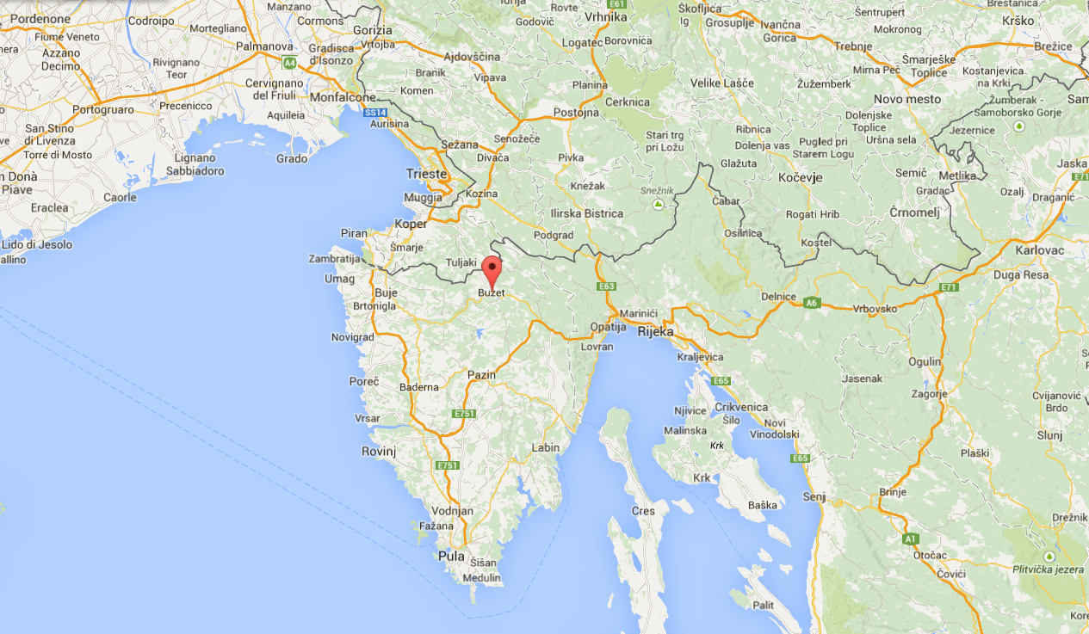

TIME TABLE
 | Venue | Date | Time
 | Buzet (Croatia) | 29 May | ADMINISTRATIVE |  | TECHNICAL
 | Country FMN |  | Time |  | Time
1 | Croatia HMS |  | 10.00 |  | 11.00
2 | Slovenia HMZ |  | 10.10 |  | 11.10
3 | Bosnia/Serbia |  | 10.20 |  | 10.20
4 | Italy FMI |  | 10.30 |  | 11.30
5 | Austria OAEMTC |  | 11.00 |  | 12.00
6 | Germany DMSB |  | 11.15 |  | 12.15
7 | Suisse FMS |  | 11.45 |  | 12.45
8 | France FFM |  | 11.55 |  | 12.55
9 | Slovakia SMF |  | 12.30 |  | 13.30
10 | Cech Rep. ACCR |  | 12.50 |  | 13.50
11 | Belgium FMB |  | 13.15 |  | 14.15
12 | Nederlands KNMV |  | 13.30 |  | 14.30
13 | Sweden SVEMO |  | 14.00 |  | 15.00
14 | Finland SML |  | 14.25 |  | 15.25
15 | Poland PZM |  | 14.55 |  | 15.55
16 | Great Britain ACU |  | 15.00 |  | 16.00
17 | Latvia LAMSF |  | 15.30 |  | 16.30
18 | Norway NMF |  | 15.40 |  | 16.40
19 | xxxxx xxxx |  | finish 16:00 |  | Finish 17:00

